Building Large Web Applications Using Dojo Toolkit and the ArcGIS® API for JavaScriptTM

The Web is the most hostile software engineering environment imaginable.

Douglas Crockford.

# Introduction

Web mapping applications tend to be large, and have lots of interaction with the users, with many different functionality.

When your Javascript application grows in size, you will find it very difficult to maintain because the language traditionally was not designed to be used in such large scale applications. For example there is no enforcements or conventions of any type, and its dynamic type gives lots of power, but at the same time, make it vulnerable to be miss used by developers.

Writing a large application without proper structure, architecture or design in mind, will most probably end up with a very bad code.

The rising importance of JavaScript in last ten years, with the more use of Ajax, and Web 2, raised the flag of the issues of JavaScript development.

To avoid this and to write neat, maintainable and scalable JavaScript applications, many libraries where developed by different teams to try to bring structure and order to the chaos of JavaScript world.

And Dojo toolkit is one of the major contributors to the JavaScript world with their toolkit.

The course is about using the Dojo tools in a practical example, where we want to target two platforms: desktop and mobile.

# Course Goals

By the end of the course, you will be able to:

* Understand composite modular system using Dojo AMD modules.
* Design an application to be different loose coupled modules.
* Write a stand-alone module that can be added to any application
* Write unit test for the stand alone module.
* Handle communication between modules, and keeping the loose couple design strategy.
* Write one code for both mobile, and non-mobile JavaScript application

# Installing the course code

Code will be provided, follow the instructions on how to setup your machine to run the code

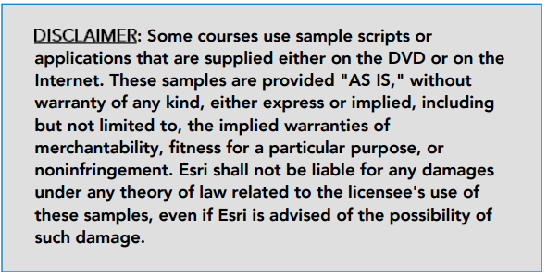

# 1

# Getting Started: Installation

# 

# Working environment

The working environment for this course

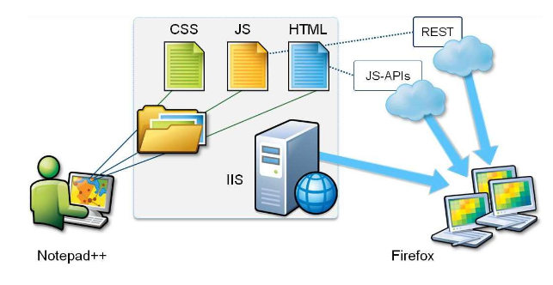

1. Copy the code directory "JavaScriptCourse" to your virtual machine hard drive c: or d:
2. So your directory for example will be c:\JavaScriptCourse.
3. From Windows Explorer, right mouse click on the folder, chose Properties, and then Sharing tab
4. Start iis manager: from the Start Menu's search box, write iis, and chose the option Internet Information Services (IIS) Manager

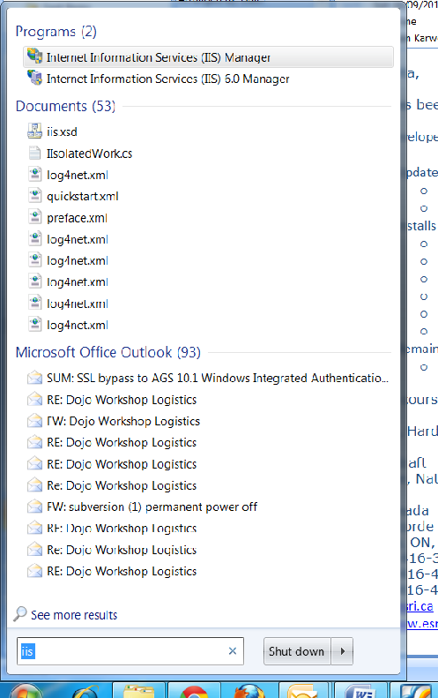

1. Select "Default Web Site"

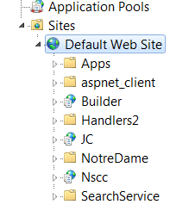

1. Right mouse click on default web site and chose add application:

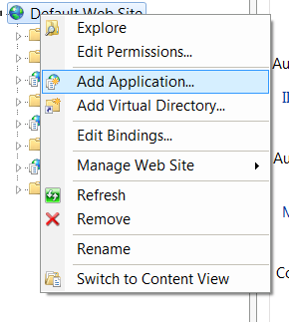

1. Add the following details

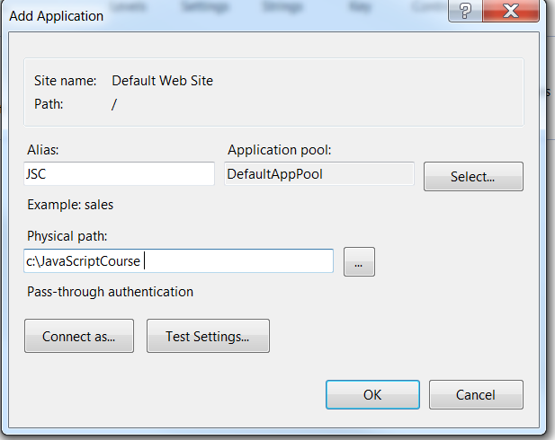

1. Test the installation from your Firefox web browser by entering

http://localhost/JSC/StartupApplication/index.html

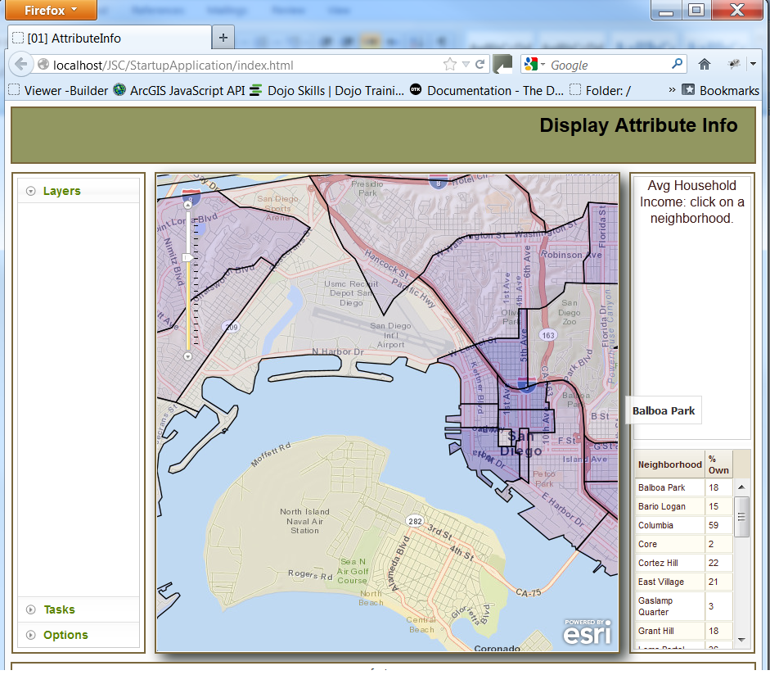

# IDE editors:

Productivity is all about the tools you use, and choosing the right IDE for you is going to affect your productivity.

We will present three major IDEs

## Aptana studio

It is open source, free and very customizable.

It reads vsdoc/jsdoc format to help with code completion.

Integration with GitHub

## Webstorm

Cheap IDE from JetBrains (50$) for personal license.

Has features that might not helpful with our development, like Live Edit

Shortcuts for editing html/javascript/css (see demo)

Integration with many SC

Support vsdoc/jsdoc for code completion

built-in support for Dojo

## Visual Studio

Many add-ins free or commercials to support JavaScript.

ReSharper 7 add support for JavaScript

Visual studio is slow and expensive

if you are doing development on Asp.NET then Visual Studio and ReSharper 7 is your best tool.

# The mission of the course:

**Our organization asked us to make a mobile version of the "StartupApplication"**

**The new version should share the business functionality with the "desktop" version. The mobile version is a skinny version of the desktop and doesn't copy all functionality, but only few of the desktop ones, and it has different layout that fit the mobile device.**

### Objectives throughout the course

* Learn tools available in Dojo toolkit that help with common requirements of a Map-based JavaScript application.
* Learn good practices in developing large scale JavaScript application.
* Learn how to minimize problems with JavaScript development.
* Learn how to use Dojo toolkit in improving your code structure.

## Exercise:

Look at the existing code and find out what is wrong with the code:

1. What are the disadvantages of defining variables and functions in the global name space?

____________________________________________________________________________________

____________________________________________________________________________________

____________________________________________________________________________________

____________________________________________________________________________________

1. What is wrong with this code?

function myFunction(input) {

output = input * 2;

}

if a developer forgot to put "var" , he/she can affect the whole code

1. What is wrong with the way we handled the events?

____________________________________________________________________________________

____________________________________________________________________________________

____________________________________________________________________________________

____________________________________________________________________________________

* from the Dojo documentation:

*This means in "modern" Dojo, if you are about to access something in the global namespace****STOP****because you are doing something wrong. While for backwards compatibility reasons the vast majority of the toolkit for the moment scopes itself globally, it shouldn't be used for new development.*

*If you find yourself typing dojo.* or dijit.* or dojox.*, something isn't right.*

*This does mean though for developers who are used to "legacy" Dojo, just including dojo.js and getting a core of functionality and the requiring in a few other modules and just typingdojo.something to your heart's content is gone (or really should be, because while it will broadly work until 2.0, it is a BAD BAD thing).*

*Again, repeat after me "the global namespace is bad, the global namespace is bad, I will not use the global namespace, I will not use the global namespace".*

## Modular application

The modular application idea, is to build your application from independent, loosely coupled modules.

Each module leaves on its own, without direct dependency on the existing of other modules.

## Dojo Toolkit Role:

Dojo toolkit provides the tools, libraries that allow us to build such application, with good structure.

# 2

# Exercise 1: Write your first module.

# Introduction

In this Exercise, we will translate the map code to be an AMD module. You will learn the following

* the new Dojo style (modern Dojo) of writing modules
* Compare it with the old style of coding
* Write a module that will show up a map on the page.
* how to initialize a module
* define a custom directory to retrieve modules, while using ESRI library from CDN

# Steps

1. Start from Ex1Before
2. Check the directory "snippets" for reference.
3. compare with the directory "Ex1After"

# Important things to remember

1. Comparing to old style Dojo, how the new style is superior?

____________________________________________________________________________________

____________________________________________________________________________________

____________________________________________________________________________________

____________________________________________________________________________________

1. What is the function of declare statement?

____________________________________________________________________________________

____________________________________________________________________________________

____________________________________________________________________________________

____________________________________________________________________________________

1. Can we define a module without returning anything?

____________________________________________________________________________________

____________________________________________________________________________________

____________________________________________________________________________________

____________________________________________________________________________________

# 3

# Exercise 2: Write a mobile version of the application.

# Introduction

In this Exercise, we will write a mobile version of the map application. You will learn:

* the basic template from ESRI to write mobile JavaScript API
* differences between compact version and normal version of the API
* Dojo mobile

# Steps

1. Start from Ex2Before
2. Check the directory "snippets" for reference.
3. compare with the directory "Ex2After"

# Important things to remember

1. What is the event when we change the orientation?

____________________________________________________________________________________

____________________________________________________________________________________

____________________________________________________________________________________

____________________________________________________________________________________

1. How the layout of the mobile version?

____________________________________________________________________________________

____________________________________________________________________________________

____________________________________________________________________________________

____________________________________________________________________________________

# 4

# Exercise 3: wire up map resize with changing dimensions.

# Introduction

When we change device orientation or we resize the browser, the map should reflect its size as well.

Both mobile and desktop have different events.

How we are going to have a unified way to handle such different events, keeping the shared code without modifying it. You will learn:

* Dojo arsenal for event handling.
* How event tools of dojo help build loosely couples modular system.
* How we can handle different events for the same module.

# Steps

1. Start from Ex3Before
2. Check the directory "snippets" for reference.
3. compare with the directory "Ex3After"

# Important things to remember

1. what are the benefits of loosely coupled modular system?

____________________________________________________________________________________

____________________________________________________________________________________

____________________________________________________________________________________

____________________________________________________________________________________

1. Why dojo event tools are important for writing loosely coupled system?

____________________________________________________________________________________

____________________________________________________________________________________

____________________________________________________________________________________

____________________________________________________________________________________

# 5

# Exercise 4: Adding the grid data.

# Introduction

Dojo has the tools to add many modules that can communicate with each others at the same time not dependent on each others. In this exercise you will learn.

* How modules can communicate with each others without depending on each other.
* Using Dojo data store and the idea of MVC.
* Writing a controller.
* The idea of a controller.

# Steps

1. Start from Ex4Before
2. Check the directory "snippets" for reference.
3. compare with the directory "Ex4After"

# Important things to remember

1. In MVC, what Controller stand for?

____________________________________________________________________________________

____________________________________________________________________________________

____________________________________________________________________________________

____________________________________________________________________________________

1. What are the benefits of MVC framework?

____________________________________________________________________________________

____________________________________________________________________________________

____________________________________________________________________________________

____________________________________________________________________________________

1. What Dojo tools used to build an MVC-based application?

____________________________________________________________________________________

____________________________________________________________________________________

____________________________________________________________________________________

____________________________________________________________________________________

# 6

# Exercise 5: Adding Unit Test.

# Introduction

Unit test is gaining more importance with the larger and live application. Books and books on how much unit test can add to the project. You will learn

* Dojo unit test framework.
* Writing a unit test for a module.
* .

# Steps

1. Start from Ex5Before
2. Check the directory "snippets" for reference.
3. compare with the directory "Ex5After"

# Important things to remember

1. Difference between unit test and integration test?

____________________________________________________________________________________

____________________________________________________________________________________

____________________________________________________________________________________

____________________________________________________________________________________

1. how unit test is achievable in Dojo modules ?

____________________________________________________________________________________

____________________________________________________________________________________

____________________________________________________________________________________

____________________________________________________________________________________

1. what benefits of writing a unit test for a module?

____________________________________________________________________________________

____________________________________________________________________________________

____________________________________________________________________________________

____________________________________________________________________________________

# 7

# Exercise 6: Adding the mouse over module.

# Introduction

This module will be used by one platform and not the second one. You will learn

* The importance of modular system to switch on/off modules.
* Writing a unit test for a module.

# Steps

* Start from Ex6Before
* Check the directory "snippets" for reference.
* compare with the directory "Ex6After"

# Important things to remember

1. How writing a modular system, helped with switching module on/off?

____________________________________________________________________________________

____________________________________________________________________________________

____________________________________________________________________________________

____________________________________________________________________________________

1. How this feature can be useful?

____________________________________________________________________________________

____________________________________________________________________________________

____________________________________________________________________________________

____________________________________________________________________________________